Locators cheat Sheet:

Download “chroPath” and add its extension to chrome browser

CSS Syntax -> tagname[attribute ='value'] or [attribute\* = 'value'] or input#IDvalue

Example: “Input[name = ‘email’]”

Using console to verify css element with Chrome:

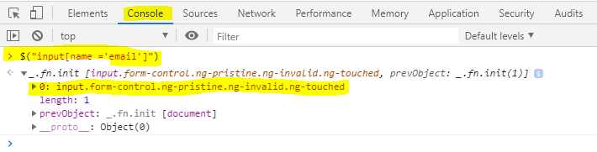

XPATH Syntax -> //tagname[@attribute = 'value'] or //\*[contains(@attribute, 'value')]

Example: “//input[@type = ‘submit’]”

Using console to verify xpath element with Chrome:

